Lamb project
Mrs. Heiney
Email: acwright@conroeisd.net

If you are thinking about raising a lamb project you need to make a decision very soon. Most lambs are purchased during the summer months or at the first of September. If you decide to raise a lamb you will need to feed the lamb twice a day at the same time each day. Lambs have to be trained to walk and to set-up. Mrs. Heiney will teach you how to get them to do this. It is your responsibility to follow through with what you are instructed to do. Lambs need fresh water daily so make sure you change the water EVERYDAY. Also lambs can wear a blanket at all times. This will help condition their skin. You need to weigh the lambs every week. You can record your weights on the board in the barn. Lambs need to be wormed every month. Mrs. Heiney will give you the wormer to use and show you how to do this. We worm lambs on the first of every month. Lambs have to be worked with everyday. They will have to be exercised when it gets closer to the show. You will get instruction on how to do this as well.

Cost: approximately $500.00 and up (we can find one to fit your budget)
Barn Fee: See school barn policies*
Feed: Honor Show Lamb (get an old coffee can to measure feed)

Supplies Sullivan's supply and Judy's Western Wares
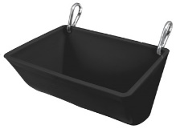
Feeder 13.50
Sullivan's Silk or 18.50 or
Mane and Tail Conditioner mix w/ water

Spray Bottle 4.95

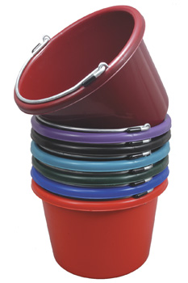
Water Bucket 6.95
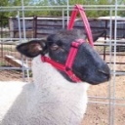
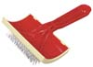
Rope Halter 3.75 or Halter from Judy's 15
Poodle Card 9.50

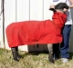
Lamb Blanket 25.00 (you will have to find out what size once you get your lamb) www.judy'swesternwares.com
Or pro-cool lamb blanket for hotter months

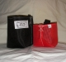
Lamb muzzle – 6.00 www.judy'swesternwares.com

